Game_Manager
The Game_Manager script is essential for this project. As the name suggests this script manages all aspects of the game. It is what uses most all of the assets/scenes/sprites/databases/scripts.

The following screenshots show case vital functions that are contained within Game_Manager along with descriptions of what the code accomplishes.
Instances of “GM” in descriptions take the place of “Game_Manager”
Instances of “SH” in descriptions take the place of “Signal_Hub”

_ready: This function of GM is called automatically by Godot when the game is launched. This function connects various other functions to signals emitted by SH. This tells GM to listen to signals and to run the function connected to that signal. This function also instantiates the current starting scene for the game.
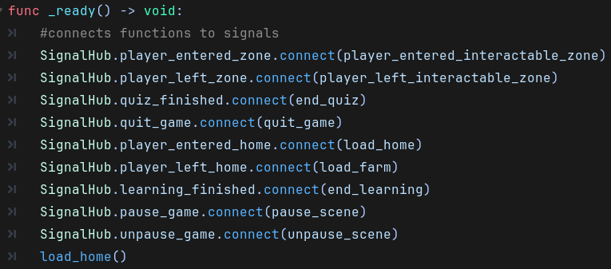
load_farm(), load_home(): These functions are responsible for freeing scenes that are currently displayed to the player. These functions also instantiate their related scenes and displays to the player. The load_farm() func calls another function called set_tree_data() this is used to give the 3 Tree scenes on the farm their associated data in order to display proper growth. Note the call_deferred function defers the execution of the code until Godot finishes processing all physics-based interaction. (I.E. area2D, staticbody2D, or collisionArea2D.)
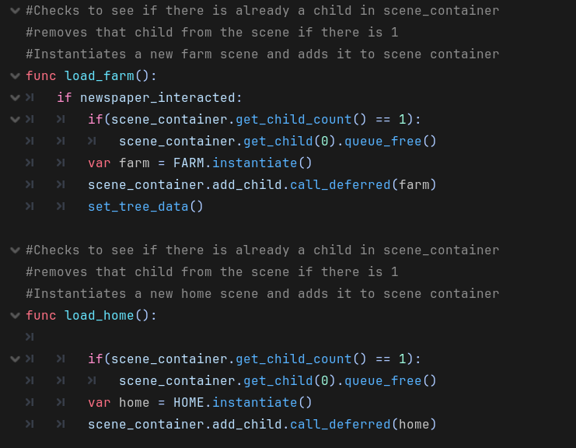

handle_interact: This function is called when the player presses the interact key, when inside the zone of an object. When the player walks into the interaction_zone of an object that information is stored in GM and is used to determine what code needs to be executed. This function uses flags to stop repeated interaction with objects that should only be interacted with once a day or when other objects are interacted with. This function calls the pause_scene function that pauses the current scene to stop input from the player to control the character or interact with an object. The last_quiz_tree variable stores the last tree the player interacted with and Is used to assign correct answers to the correct tree’s data set held by GM
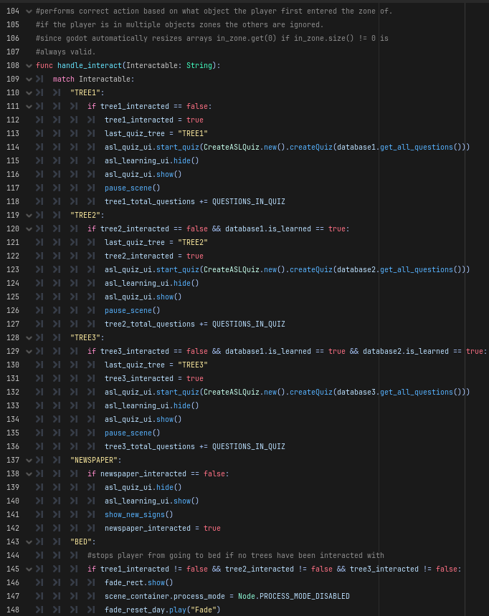
show_new_signs(): This function is called by handle_interact when the player is interacting with the newspaper in the home scene. This function uses asl_learning_ui and other ASL Learning classes to pick up to 4 ASL Signs not currently unlocked by the player, display, and unlock them. This function uses a Boolean variable called one_db_used. This is used to prevent data bases from mixing and unlocking signs from different data bases in one learning.
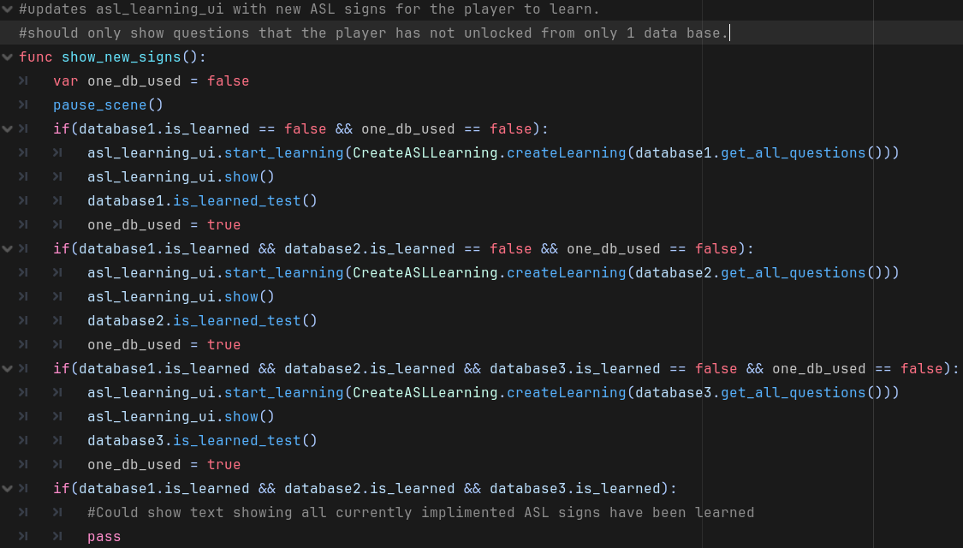

end_quiz(), end_learning(): These to functions handle when either a quiz has ended or the player feels they have learned the 4 new ASL Signs and is ready to move on. The questions answered correctly by the player are added to the correct variable based on the last tree the player interacted with.
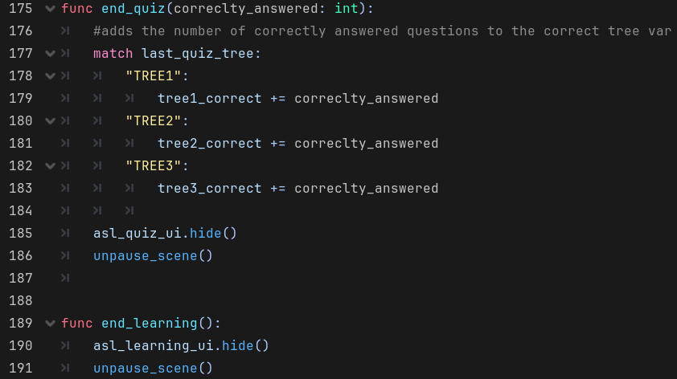
set_tree_data(): Stores the current tree information into tree_data and emits that data via signal, using signal hub. This is used by Tree scenes to correctly assign growth levels each time the farm scene is instantiated.
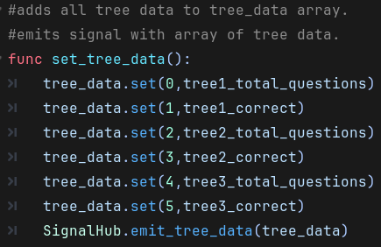

quit_game(), player_entered_interactable_zone(),
player_left_interactable_zone(): The quit game function is used when the quit_game signal is emited. The other 2 functions are used to store what object the player is currently in the interaction zone of. If a player enters an interaction zone of an object the object is added to the in_zone array of Strings. If the player leaves an interaction zone of an object the object is removed from the in_zone array of strings. These functions use the signals player_entered_interactable_zone and player_left_interactable_zone. These signals are emitted by the corresponding emit function in SH when called by either a Tree, Newspaper, or Bed scene.
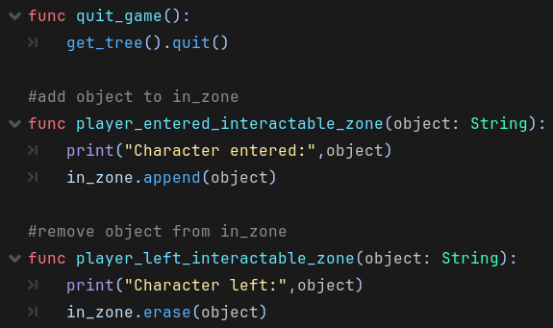
_on_fade_reset_day_animation_finished(): This function is connected to a signal not emmited by signal hub, but instead emitted by an animation player when the animation has finished player. This particular animation is used when the player interacts with the bed. When this happens the screen fades to black, then fades back in to reset the day. All flags that indicate an object has been interacted with resets to false and the unpause_scene is called to allow the player to move and interact with the character again.
